**CAPTAINS** 1. FISHING SHIPS, METHODS AND GEAR.

###### *Exercise.* Make lists of verbs and expressions related to fishing which are in the texts in pages 1 to 15. They’ve already been marked in black. Try to guess their meaning:

<http://fishcount.org.uk/fish-welfare-in-commercial-fishing>

## [purse seining](http://fishcount.org.uk/fish-welfare-in-commercial-fishing/capture/purse-seine)

In purse seining a **school of fish** is gradually **encircled** by a long **wall of netting**, possibly as long as 1 Km, hanging in the water and **towed into a circle**. Once the circle is complete, the net is drawn together like a draw-string bag, constraining the fish. The fish are then **hauled aboard** within the net, pumped to the deck, or **scooped into** smaller **brail nets** (TRUELES) and lifted aboard.

##### Fish try to out-swim the net moving towards them and they are finally encircled.

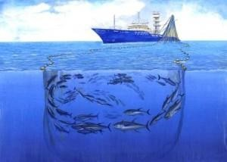Sometimes fish are deliberately scared by, for example, high speed chase boats used **to herd the fish**. Once the circle is complete, the **trapped fish** are confined in a shrinking space of water and become increasingly crowded. At a certain point, the constriction of space will prevent the fish from swimming as a school, instead they will move as

individuals. Fish are liable to incur injury and **scale** loss from collisions with other fish and with the **net walls**.

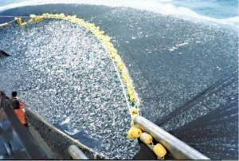

Fish can also receive further injury as they are transferred to the fishing vessel. Pumps can break **fins** and damage scales. In **ramping**, the seine net is hauled aboard en mass, causing fish to get crushed. In **brailing**, fish are transferred using a smaller brail net.

Lower **death rates** have been found in

salmon transferred by this method as compared with ramping.

<https://www.youtube.com/watch?v=4JUKvrfaslM> [How Seafood is Caught: Purse](https://www.youtube.com/watch?v=4JUKvrfaslM) [Seining](https://www.youtube.com/watch?v=4JUKvrfaslM)

Sometimes purse seine nets are deliberately set on dolphins, in order to catch tuna that swim with them. However, the alternative of setting nets on **fish aggregating devices** (**FADs**) produces much greater numbers of **bycatch animals**, mainly fish). Environmental groups such as Greenpeace and WWF therefore support a cleaner method of fishing, monitored by an observer programme, which sets on dolphins but allows them to escape before the **net is hauled in**. Bycatch is less of a problem when seine nets are just set on a free-swimming school of fish, rather than on dolphins or FADS.

Sometimes part of the catch (i.e. excess catch) is **deliberately released** from the **tightened net** instead of landing it, in a process called **“slipping”**. Despite the fact that these fish are released alive, high death rates can occur following release as a result of injury and scale damage incurred. Possible ways to reduce these wasteful death rates are for fish to be released before the net is tightened and reducing the practice altogether.

**Overfishing** is a major environmental problem and is discussed in [reducing numbers.](http://fishcount.org.uk/?page_id=86&overfishing) This is so in all fishing methods here discussed.

***Measures to reduce suffering in purse seining***

The following measures, **combined with humane slaughter immediately the fish are landed (***this should be done for all methods here described***)**, would reduce the suffering of fish captured by purse seines:

**Reducing the suffering in purse seining:**

##### Reduce the duration of capture

* Reduce the duration of the whole capture process
* Reduce the time spent in the net once it has been pursed and constricted ready for, and during, landing when the fish are most crowded and vulnerable

Reduce the numbers of bycatch animals

* Avoiding fishing on FADs
* Use encirclement methods that avoid harm to cetaceans
* Use gear modifications shown to reduce bycatch, e.g. sorting grids, without killing the escaping fish
* Close fisheries as and when necessary to reduce high levels of bycatch Reduce stress and injury to bycatch fish
* Reduce the practice of slipping
* For catch to be partially “slipped”, do so before the net is tightened ready for landing
* Use gears which enable quick release of fish during slipping Reduce stress and injury during landing
* Avoid the practice of ramping to land fish
* Develop and use methods of landing fish which reduce stress and injury, and minimise time out of water (e.g. aquaculture pumping systems that minimise stress and damage could potentially be adapted for use on boats)
* Handle fish carefully prior to humane slaughter (or release as bycatch)

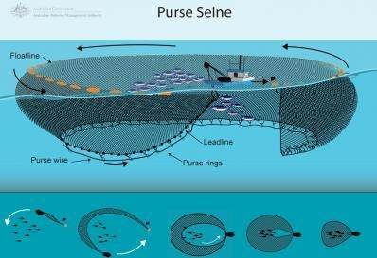

**PURSE SEINE FISHING** is mainly used to catch fish species that swim in large schools near the ocean surface.

**How purse seine works:** In a purse seine the top of the net is floated at the ocean’s surface and the **bottom of the net** has **weights** attached that pull the walls of the net downwards.

**The bottom of the net has a wire threaded through it** which is pulled and tightens the net like a purse trapping the fish inside.

The net is then **pulled in** toward the boat and the catch is either pumped or **lifted out**

with small nets or the whole net is **brought aboard**.

The size of purse seine nets can be varied, depending on what **species** is being

###### targeted.

**Environmental impacts and management**

The purse seine method of fishing is **very selective** as it usually **targets** only **one species** at a time. This means that there is very **little impact** from purse seine fishing on other marine species. Purse seine **nets are set** near the ocean surface and do not touch the **sea floor**, so their impact on the marine environment is also very small.

In some countries, purse seine nets may be set around a floating object such as ocean debris. These objects are called Fish Aggregating Devices (FADs) and large numbers of fish are often attracted to these. This means that if a purse seine net is set around a FAD, many other marine species may be caught.

## [TRAWLING](http://fishcount.org.uk/fish-welfare-in-commercial-fishing/capture/trawl)

##### Fish caught by trawling are chased to exhaustion by a **bag-shaped net towed through** the water. Once exhausted, the fish become swallowed by the net and start to move into the much narrower **cone-shaped part** of it. As they thrash their **tails** in attempts to escape, they will incur scale damage from bumping against the net and each other. Eventually they pass to the end of the net, called the **cod-end**, which is yet narrower. As the number of fish in the cod-end increases, the fish will experience compression under the crush. This may stop some of them being able to move their **gills** in order to breathe, resulting in suffocation. It may also stop the blood supply, resulting in death from circulatory failure.

The trawl tow may last for many hours. For species that have a closed **swim bladder**, the sudden change in pressure caused by raising them from some depth, results in rapid decompression. Parts of the **gut** may be forced out of the mouth and anus, eyes may be forced from their orbits and the swim bladder may burst.

Trawl nets catch everything in **their path** which is not small enough to escape through the **holes in the mesh**, resulting in bycatch.

##### Trawls **towed along the sea bottom** (bottom trawls) can also be highly damaging to the seabed, destroying fish habitat if sensitive habitat areas like corals, sponges and seagrass beds are trawled.

<https://www.youtube.com/watch?v=BcJFSl_YJHk> How Seafood is Caught: Bottom Trawling <https://www.youtube.com/watch?v=JYiFJEx6qPY> How Seafood is Caught: Midwater Trawling

Fish that are thrown back into the sea after **landing** because they have been identified as bycatch, often die as a result of capture. So, too, do some fish that are caught in trawl nets and subsequently escape. **Escapee and discarded fish** may die from injury, or from being too exhausted or stressed to adequately evade predators or from infection following scale damage.

Trawl gear may theoretically be made “selective” by modifications called **bycatch reduction devices (BRDs)**. BRDs work by allowing **unwanted species** to escape though holes in the net while retaining the target species. For gear to be truly selective, the fish escaping through the BRD must be sufficiently unharmed to survive. Another method of bycatch reduction is to reduce fishing effort, e.g. by closing a **fishery** at a particular time and place when bycatch levels are particularly high.

For some species, the survival chances of discarded bycatch are likely to be increased by **better handling of the fish on deck** (especially reducing time spent out of water). Survival chances are also likely to be increased with **shorter time spans between putting the net out and landing the fish**. Other factors, such as **tow speed**, temperature and depth, can also affect the survival chances for escapees ( fish that are caught in trawl nets and subsequently escape) and/or discards.

***Measures to reduce suffering in trawling***

**Reducing the suffering in trawling:**

Reduce the duration of capture

* Reduce the duration of the trawl tow Reduce the numbers of bycatch animals
* Develop and use modifications to trawl gear that reduce bycatch, without killing the escaping fish
* Research and use other measures to reduce the numbers of escaping (and discarded) fish that die e.g. tow speed
* Close fisheries as and when necessary to reduce high levels of bycatch Reduce stress and injury during landing
* Avoid fishing from depths greater than 20m (for fish with swim bladders)
* Develop methods of landing fish which reduce stress and injury and minimise time out of water
* Handle fish carefully, and with minimal time out of water, prior to humane slaughter (or release as bycatch)

Reduce harm to other non-target animals

* Avoid gears that are more damaging to fish habitat

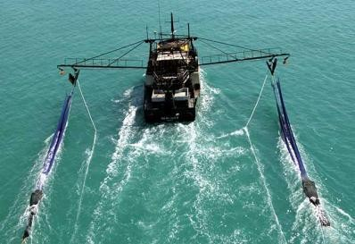

**TRAWLING** is one of the most common methods of fishing. Trawl nets are designed to be towed by a boat through the **water column** (midwater trawl) or along the sea floor (bottom trawl).

Trawl nets are **shaped like a cone or funnel** with a wide opening to catch fish or crustaceans and a narrow, closed ‘cod-end’. Trawls can be used at various depths and nets differ by their **mesh size**.

Both bottom and midwater trawls use **otterboards/trawl doors** to keep **the mouth of the net** open.

[**Bottom trawl**](https://www.afma.gov.au/fisheries-management/methods-and-gear/trawling#accordion-bottom_trawl-994)

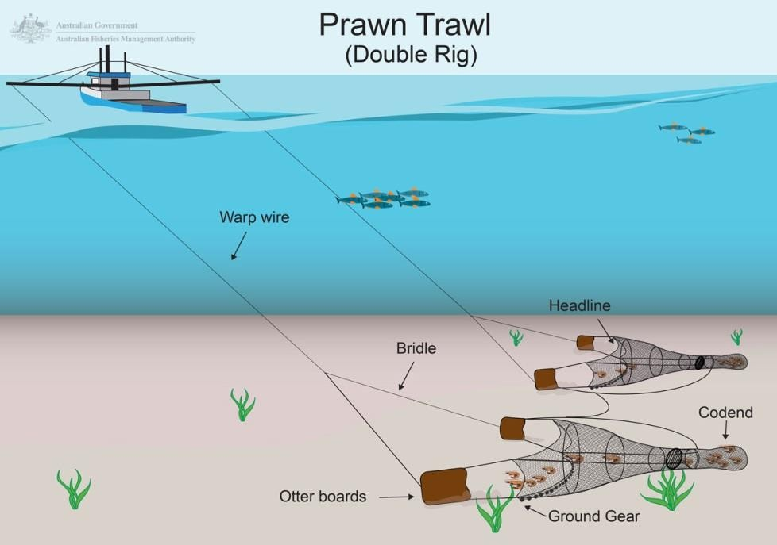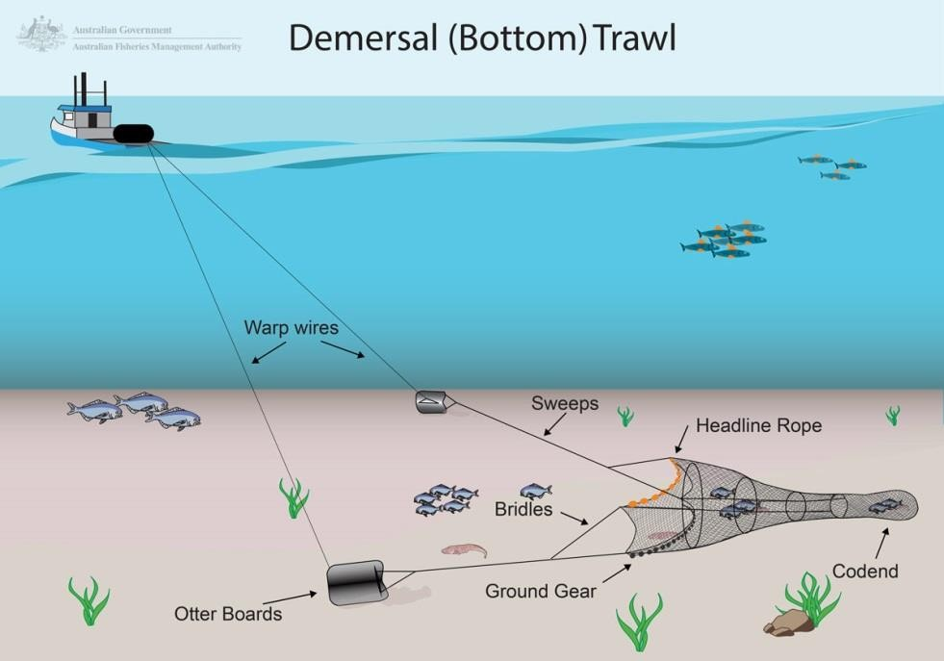

**How bottom trawls work:** Bottom trawls use **trawl boards/doors** normally made of

steel, to keep the mouth of the net open and on the bottom.

Trawl nets are designed differently depending on whether the target species is fish or prawns.

**Fish trawls** are towed as a single net over the back end of a boat, **ramp,** to set and

###### retrieve the net.

Fish trawls have long metal cables, called **sweeps**, connecting the trawl boards with the net which allow the boards **to spread** much further than the overall width of the net. The sweeps ‘herd’ fish until they tire and drop back into the net where they are finally caught. Trawl nets have **bobbins or rollers** on the **ground gear** to allow the net to move over the sea floor without **snagging** and to minimize bottom contact.

The sizes of trawl nets vary, however there are minimum mesh size restrictions in place for certain **fisheries**.

**Prawns trawls** can be towed **in multiples of two, three or four nets**, with long arms (or **booms/boom derricks**) extending out from each side of the boat to allow the nets to fully open. When fishing the booms will be parallel to the water surface; when transiting the booms are normally topped *(poner por encima)* at a 45 degree angle to the water surface for stability and in harbour the booms are often topped vertically

Prawn trawl nets use **ground chain for weight** so it skims the **seabed** and encourages prawns living on the sea floor up into the trawl mouth. Prawn trawl nets don’t have long sweeps and the nets have smaller mesh than fish trawls.

### [Midwater trawl](https://www.afma.gov.au/fisheries-management/methods-and-gear/trawling#accordion-midwater_trawl-798)

**Midwater** trawls fish in the water column and are used to catch a variety of **pelagic fish** species. Midwater trawl nets may incorporate **acoustic technology** to tell the skipper the position of the net in the water column, the **opening/spread of the net** and the volume of fish entering the net.

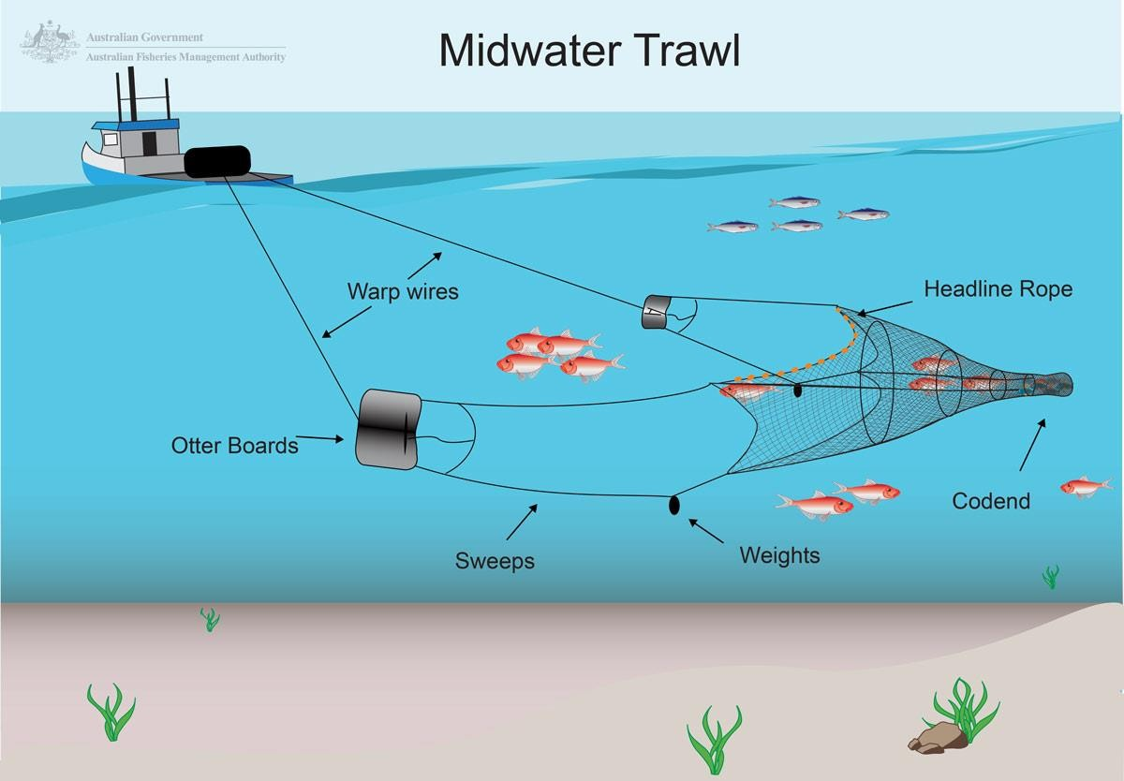

**How midwater trawl works:** Midwater trawling involves towing a net behind a boat to catch fish species. The net is connected to the boat by the **warp wires** and the opening to the net is spread using two large boards known as otter boards. **The net is towed off the bottom in depths from just off the bottom to near the surface**. Midwater trawl nets are usually shaped like a cone or a funnel with a wide opening to catch fish and a narrow end called a codend where **fish are collected**.

###### Environmental impacts and management

Midwater trawl gear has minimal impact on the environment primarily because it doesn’t come into contact with the seabed. [Seals](https://www.afma.gov.au/portfolio-item/seals) were identified as one of the species at risk from midwater trawling in the freezer boat sector, however these boats may use [**seal exclusion devices**](https://www.afma.gov.au/portfolio-item/seal-excluder-devices) or ‘SEDs’. In 2013 a ‘**hydrostatic release’** to keep nets

closed until they are too deep to be reached by seals looking for food was tested. This was effective in further reducing the risk of seal deaths.

## [GILLNETTING](http://fishcount.org.uk/fish-welfare-in-commercial-fishing/capture/gillnet)

##### A gill net is a wall of netting, hanging in the sea, which is invisible to fish. Fish of a certain size, swimming into a gill net, will get their **heads stuck** and **become snared** as they try to reverse. As the fish struggles to free itself, it may become yet more entangled. Constriction of the gills by the netting may also stop the fish being able to breathe properly. Struggling may result in cuts to the skin and scales. The snared fish may then also suffer attack from predators such as seals, leaving it wounded.

A **trammel net** is a variation of gill net with **2 or 3 layers**. 28% of the fish caught in a trammel net died in the net, probably from suffocation caused by constriction of the gills. Another 16% died following release, having incurred open wounds.

Further injury to skin and scales may be caused when the net is hauled in over **roller guides** and in removal from the net. Loosely attached fish may be **gaffed** (i.e. their bodies **spiked** with a **hand held hook**) to bring them onboard. Snared fish are then pulled out by hand or removed by **shaking the net**.

Sometimes marine turtles, birds, and mammals are **tangled** in gillnets and **drown**. Cetacean and bird bycatch can be reduced by use of **acoustic devices (“pingers”)** to make the nets more “visible” to them.

##### The numbers of discard fish that die following release from gill nets is likely to be very high in some fisheries. The smaller-meshed tangle nets tended to **catch fish round the snout** rather than snaring them. This resulted in less injury. However, the smaller- meshed tangle nets did result in larger numbers of bycatch animals.

More careful handling of the fish can help reduce the numbers of discarded fish that die. A study found that the number of fish dying in the nets was related to the **twine type** and water temperature and, as well as increasing with **soak time** (i.e. the period of time

**between setting and retrieving the net**). Fish were more likely to die in **monofilament nets** than in **multifilament nets**.

##### Lost gillnets may continue to catch fish **(“ghost fishing”**) for several months or even years. The problem can be partially addressed by constructing nets from materials that deteriorate more quickly and by “retrieval surveys” in which vessels survey fishing grounds to retrieve lost nets.

***Reducing suffering in gillnetting***

**Reducing the suffering in gillnetting:**Reduce the duration of capture

##### Reduce the time between setting and retrieving the net (the [fair-fish](http://fishcount.org.uk/?page_id=117&fair-fish) fish welfare certification scheme limits capture duration to 30 minutes).

Reduce the numbers of bycatch animals

* Use gear modifications shown to reduce bycatch e.g. pingers to deter cetaceans
* Close fisheries as and when necessary to reduce high levels of bycatch
* Use gear made from biodegradable materials to reduce ghost fishing
* Survey fishing grounds for, and retrieve, lost and discarded gill nets Reduce death rates for bycatch animals
* Avoid fishing in warm-water weather when fish are likely to be particularly stressed

Reduce stress and injury during capture

* Use gears that entangle fish rather than gilling them e.g. tangle nets rather than gill nets
* Use gear type variations that reduce injury e.g. knotless multi-filament nets are preferable to mono-filament nets

Reduce stress and injury during landing

* Avoid gaffing fish
* Handle fish carefully when landing and removing from nets, prior to humane slaughter (or release as bycatch)

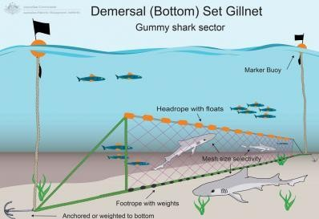

**How gillnets work** [**https://www.youtube.com/watch?v=MLtknnZunrE**](https://www.youtube.com/watch?v=MLtknnZunrE)How Seafood is Caught: Gillnetting

Gillnets are **long rectangular panels of netting** with **diamond-shaped mesh** that are

**held vertically in the water column** and anchored to the ocean floor at either end.

Fish swim into the net and are entangled by the gills, fins and spines. The nets are kept vertical by the **floats along the top** and **weights along the bottom**.

Only **demersal gillnets** (touching the ocean’s floor) are permitted in Commonwealth and Spanish fisheries. Gillnets are normally used in continental shelf waters (AGUAS DE LA PLATAFORMA CONTINENTAL) less than 100m deep.

###### Environmental impacts and management

Gillnets have a minimal impact on the **substrate** as they are **static when set**. Gillnets have the potential to interact with marine mammals, although when set properly, larger predatory sharks and marine mammals will **bounce off the tight mesh**.

## [LONG LINE FISHING](http://fishcount.org.uk/fish-welfare-in-commercial-fishing/capture/long-line-fishing)

##### Long line fishing, or long lining, is a commercial fishing method that uses hundreds, or even thousands, of **baited hooks** hanging from a **single line** which may be 50-100 km long. Unlike other hook and line fishing methods, the duration of capture for long line fishing is very long. Fish caught on long lines are landed hours, or days, later when the gear is hauled up. As with all forms of hook and line fishing, sometimes fish are [**gaffed**](http://fishcount.org.uk/?page_id=2918&gaffing) (i.e. impaled on a hook) to bring them abroad.

In this method of fishing, it is common for [live fish to be used as **bait**](http://fishcount.org.uk/?page_id=512&livebait). A **semi- automatic machine impales** the live fish on hooks as **the line is played out**. Once

##### **hooked**, the fish may themselves be subsequently attacked by predators and may be dead when landed.

Environmental impact

Long lines kill sea birds, sea turtles and sharks, as well as **non target fish**, which are attracted by the bait. Sea birds like albatross get hooked when the lines are near the surface. The birds are then dragged under water and drowned. Bird bycatch can be reduced by measures such as **bird-scaring devices** and **weighting the lines** to make them **sink more quickly**. US fishermen can avoid the migratory paths of sea turtles by sinking their long lines deeper.

Large numbers of bycatch fish are reportedly caught and thrown back dead. Long line fishing catches more sharks as bycatch than any other fishing method on the high seas.

Levels of hooking injury, and the survival chances of released bycatch fish, are affected by the type/size of the hook/bait and the method by which the hook is removed.

***Measures to reduce suffering in long line fishing***

**Reducing**

**the**

**suffering**

**in**

**long**

**line**

**fishing:**

Reduce suffering of bait fish

* Avoid the use of live bait fish
* Avoid the use of bait fish generally (use artificial baits or off cuts instead)

Reduce the duration of capture

* Reduce the time between setting and retrieving the lines ([fair- fish](http://fishcount.org.uk/?page_id=117&fair-fish) limits capture duration to 5 minutes for fish caught by hook)

Reduce the numbers of bycatch animals

* Use hooks and baits that reduce bycatch
* Close fisheries when necessary to reduce high levels of bycatch
* Use measures shown to reduce bycatch e.g. sinking lines to avoid seabird bycatch

Reduce death rates in bycatch fish

* Avoid fishing in warm-water weather when fish are likely to be

particularly stressed

Reduce stress and injury during capture

* Use hooks than cause less injury e.g. circle hooks, barbless circle hooks
* Avoid fishing from depths greater than 20m (for fish with swim bladders)

Reduce stress and injury during landing

* Handle fish carefully when landing prior to humane slaughter (or release as bycatch)
* Minimise time spent out of water
* Remove hooks after fish is humanely slaughtered or stunned, rather than before
* Carefully remove hooks from fish to be released
* [Avoid gaffing](http://fishcount.org.uk/?page_id=2918&gaffing) fish

[**Pelagic longline**](https://www.afma.gov.au/fisheries-management/methods-and-gear/longlining#accordion-pelagic_longline-582)

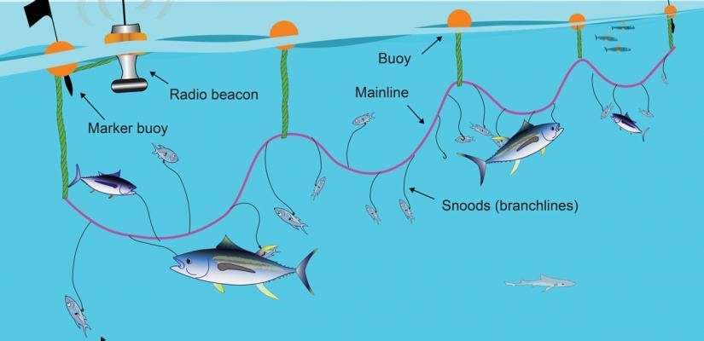

Pelagic (mid-water) longline

**How they work:** Baited hooks are attached to the longline by short lines called **snoods** that h**ang off the mainline**. The longline can be many kilometres long and can carry thousands of hooks.

Pelagic longlines are not anchored and **are set to drift** near the surface of the ocean with a radio beacon attached so that the vessel can **track** them to **haul in the catch**

# [Bottom/Dermersal longline](https://www.afma.gov.au/fisheries-management/methods-and-gear/longlining#accordion-bottom_longline-731)

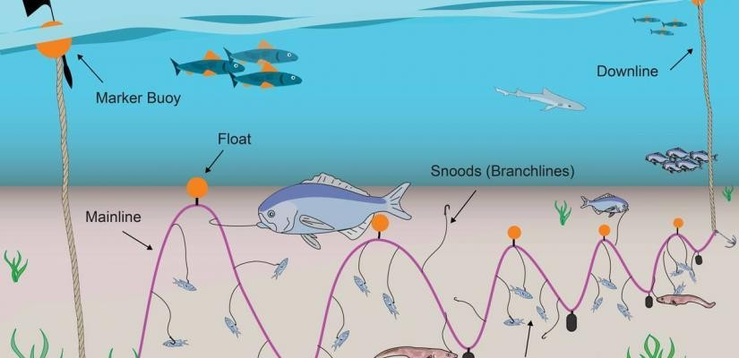

Bottom (demersal) longlines are set horizontally along the ocean floor, and are held in place using anchors. The primary difference between bottom longline fishing and auto longline fishing is that hooks are baited by hand rather than by a machine.

When set, the longline can be many kilometres in length and have several thousand hooks.

**How bottom longlines work:** Bottom longline gear consists of **a rope mainline with baited hooks spaced every 2 to 5m on monofilament or braided cord** *(trenzados)* **snoods**. The mainline is attached at both ends to **downlines** which have a large buoy on the surface for locating gear, and anchors at the bottom **to hold the gear in place**. Hauling is done **using hydraulic winches which are fixed to the deck of the boat**. The gear can be **hauled from either end** by retrieving the downline.

###### Environmental impacts and management

Bottom longline fishing causes very little damage to the sea floor and has only a very limited level of bycatch. Gear can become snagged *(capturado)* on the bottom and get broken off, although this is not a common occurrence.

Fish which have been hooked are brought to the surface slowly, and are often alive when they reach the boat, which greatly increases the likelihood of **survivability** for **non-target species** returned to the water.

<https://www.youtube.com/watch?v=yzkdXFh7N6A>How Seafood is Caught: Longlining

**INSPECTION AT SEA HANDBOOK 2017 version.pdf** EFCA (European Fisheries Control Agency) – CORE CURRICULUM FOR THE TRAINING OF **FISHERIES INSPECTORS AND UNION INSPECTORS**

*Exercise. Which modal verbs do you find in the first three pages of this text? What do they* mean?

**VERIFY THE COOPERATION OF THE MASTER**

An effective inspection requires the cooperation of the master and crew to provide access to the vessel, the catch on board, fishing gear, equipment and documentation.

(a) The master and crew shall:

* facilitate the safe and effective access to the vessel by the inspectors;
* provide a compliant boarding ladder;
* provide such assistance as is necessary and reasonable;
* permit the inspectors to communicate with the authorities;
* alert the inspectors to any safety hazards;
* provide access to all parts of the vessel, catches, fishing gear and all relevant information and documents, including electronic databases;
* facilitate safe disembarkation on completion of the inspection;
* not obstruct, intimidate or interfere in the performance of the inspectors’ duties.

***Powers of inspectors***. Inspectors should have sufficient legal powers to examine all relevant areas, decks and rooms. They may also examine catches, processed or not, nets or other gear, equipment, containers and packages containing fish or fisheries products and any relevant documents or electronic transmissions which they consider necessary to verify compliance with the rules of the common fisheries policy. They may require the master to retrieve the fishing gear from the sea. They may also question persons estimated to have information on the matter that is the subject of the inspection.

***Conduct of inspectors***. Inspectors should not require the master of a fishing vessel that is being boarded or disembarked from to stop or manoeuvre during fishing; however they may require the master to delay the shooting or hauling of gear for up to 30 minutes to permit safe boarding. The 30-minute limit does not apply in the case of infringement. The inspectors should conduct inspections in such a way as to cause the least possible disturbance or inconvenience to the vessel and, as far as possible, prevent any degradation of the catch during the inspection. Inspectors shall not interfere with the right of any master to communicate with their flag state authorities during inspection operations. Inspectors should normally limit the length of time of an inspection to 4 hours and the number of inspectors deployed to two in inspections where no infringements are discovered

*Exercise. Add titles to these activities related to Pilot on board, choosing from those below:*

***Boarding and disembarking - Assistance to inspectors - Inspection of gear - Inspection of fish holds*** - ***Pre-boarding - Inspection of catch on deck***

1. **.** The inspectors should assess the safe access to the vessel and the general assistance of the master and crew to give full and open access to all documents, catch, gear and hold spaces. Inspectors should satisfy themselves that the master understands what is required of him and they should note any obstruction and interference with the inspection.
2. **.** Contact must be attempted with the fishing vessel using VHF radio. The master should be requested not to haul the gear until the

inspection team is on board the vessel so that they can observe if the fishermen try to remove any illegal attachments, for example a blinding net on a beam trawl. However, the inspectors should be aware that they may not require the vessel to be manoeuvred or for it to stop hauling or shooting gear. The inspectors may however require the gear to be hauled for inspection. The inspector may request a delay of up to 30 minutes in shooting gear to allow safe boarding or disembarkation.

1. **.** The master and the crew of the fishing vessel should cooperate with the boarding team to allow them to get on board the fishing vessel safely. The master should be requested to steer a safe course if required, and if possible according to the fishing operation, to allow a safe boarding. There should be agreement on which side the boarding boat (RIB) goes alongside, preferably the lee side, and the vessel should keep a steady course and speed. The crew must take the headline of the RIB if required and assist the members of the inspection team to get on board if necessary. Once on board the crew should direct the inspectors to the master. The same considerations apply to disembarking from the fishing vessel.
2. **.** The crew of the vessel must assist the inspectors in manoeuvring the fishing gear on board so the inspectors have access to those parts they wish to measure. Without this assistance, it would be very difficult, for example, to examine a net on a trawl winch or to measure the length of a beam trawl. It is important that the master, or his delegate (whose name should be taken), observes the inspector taking their measurements to avoid any disagreements. It is useful to call the measurements out loud so that they can be heard and for the master to see how they are recorded.
3. **.** On deck the crew should assist the inspectors in their examination of the catch in the last haul and this catch should not be sent down to the fish hold or processing area until the inspectors have examined these areas and indicated that the fish may be moved.
4. **.** It is essential for safety purposes that the master or his delegate (often the mate) accompanies the inspectors into the fish holds and processing spaces. The crew should assist the inspectors in the hold by moving boxes or cartons of fish so that they may be examined.

###### VERIFY THE FISHING ACTIVITY

The application of a wide variety of regulations depends on the fishing activity in which the vessel is engaged. It is therefore important to verify if the vessel is actively fishing at the time of inspection and to verify the fishing method.

1. *Active and passive gear*. Fishing gear is commonly classified in two main categories: passive and active. This classification is based on the relative behaviour of the target species and the fishing gear. With passive gears, the capture of fish is generally based on the movement of the target species towards the gear (e.g. long-lines), while with active gears capture is generally based on an aimed chase of the target species (e.g. trawls).
2. *Definition of fishing*. Fishing activity and fishing operations include all activities connected with searching for fish, the shooting, towing and hauling of active fishing gears, setting, soaking, removing or resetting of passive fishing gears, taking catch on board, removal of catch from the fishing gear and transhipping, retaining on board, processing on board, transferring, fattening and landing of fish and fisheries products.

***How to verify the fishing activity***. The following is a list of some indicators of the fishing activity that may be observed.

* Normal navigation (not engaged in fishing). The vessel is navigating in a straight line between port and the fishing grounds or between fishing grounds, steaming at the normal speed of the vessel with no fishing gear in the water. At night only the navigation lights should be shown although in reality some vessels steam with fishing lights switched on. Similarly some vessels steam with a fishing day-marker shown.
* Searching for fish. The vessel is on the fishing grounds searching for fish with no fishing gear in the water. Normally seen on fishing vessels fishing for pelagic species, the vessel moves slowly or is stationary whilst she uses her sonar to find fish.
* Shooting, towing or hauling of active fishing gears. All types of trawlers may be seen shooting or recovering the fishing gear, which will be in the water close to the vessel or being handled on the vessel. On single boat trawlers the trawl doors may be seen entering or leaving the water. Whilst towing, the warps may be seen leading aft from the stern of the vessel, under tension and at an angle entering the water as the vessel moves forward. Pelagic trawlers and beam trawlers tend to tow the fishing gear at a higher speed (typically 5 to 8 knots) than demersal trawlers (typically 3 to 5 knots). All types of trawlers move faster as they shoot the gear and slower (sometimes dead in the water or even moving astern) as they haul the gear.
* Setting, soaking removing or resetting of passive fishing gears. Seine net vessels (demersal and pelagic) set the fishing gear in a circle. A demersal seine vessel then hauls the gear moving slowly forward or from a stationary position. A pelagic purse seine vessel recovers the gear from a stationary position, sometimes moving laterally to keep clear of the gear in the water. Fixed net and longline vessels shoot and haul the gear moving slowly forward. Sometimes the gear is set in a number of parallel rows. Marker buoys will be seen at each end of the gear and at intermediate points between the ends.
* Taking catch on board, removal of catch from the fishing gear. The fishing gear will be in the water close to the vessel and the catch removed by a pump or net brail or the gear will be recovered onto the vessel where the catch will be removed. Part of the gear such as a trawl may remain in the water whilst part of the net is taken on board to remove the catch.
* Transhipping. The catching vessel will be seen alongside the receiving vessel; both will be stationary in the water and the receiving vessel may be at anchor. The transfer of catch from one vessel to another may be seen. Often there are many seabirds in the vicinity to take fish dropped into the sea.
* Processing on board. The vessel may process the catch whilst stationary, under way or fishing. It is difficult to determine if the vessel is processing without being on board her. Often there are many seabirds in the vicinity to take fish offal that has been discarded into the sea.
* Transferring. Catches of highly migratory fish may be seen being transferred at sea between two vessels.

###### FISHING LICENCE

It is necessary for the inspector to check this document in order to know if the vessel may be used for commercial fishing activity. A fishing licence is an official document, issued by the national authorities, giving the holder of the licence the right to use the fishing capacity of a fishing vessel for the commercial exploitation of fisheries. The fishing licence contains, as a minumum, information concerning the identity of the vessel, the owners, the principle dimensions and the fishing gear of the vessel. It may be combined with the certificate of registry to form one document. EU legislation lays down how licences may be issued, managed and withdrawn by the flag Member States and the minimum information that must be contained in them. This information must be consistent with the information recorded in the Union fleet register and recorded on the European Commission website. A fishing licence is valid for one EU fishing vessel only. The fishing licence may be suspended temporarily or permanently withdrawn by the flag Member State if the vessel is subject to enforcement action following a serious infringement. The licence may also be suspended or withdrawn under Union schemes, implemented by the Member States, for the adjustment of fishing effort or capacity.

The master should be asked to produce the fishing licence. The inspector should check the existence of the following data and cross-check with other sources of data and observations, such as the certificate of registry and an observation of the method of fishing in use:

* Union fleet register number;
* name of fishing vessel (if any);
* flag state/country of registration;
* port or district of registration (name and national code);
* external marking;
* international radio call sign (IRCS) (if required under national rules);
* name and address of licence holder, fishing vessel owner and fishing vessel agent;
* engine power (kW);
* tonnage (GT);
* length overall;
* main fishing gear;
* subsidiary fishing gears.

It is not permitted to use a vessel without a valid fishing licence for the commercial exploitation of living aquatic resources and an inspector encountering such a vessel should consider enforcement procedures. The inspector should investigate any discrepancies such as the document being out of date or missing data such as the lack of an entry for fishing gear. If the data in the licence are incorrect without a satisfactory explanation, the inspector should

consider infringement procedures. The data on the licence should be noted and entered into the inspection report.

###### FISHING AUTHORISATION

A fishing authorisation is an authorisation issued to an EU fishing vessel operating in EU waters in addition to its fishing licence, entitling it to carry out specific fishing activities. The fisheries or fishing zones where specific fishing activities are authorised are those subject to:

* + a fishing effort regime;
  + a multiannual plan;
  + a fishing restricted area;
  + fishing for scientific purposes;
  + other cases laid down by EU legislation.

In these fisheries and zones, fishing activity may only be carried out in accordance with a valid fishing authorisation issued to the vessel. The fishing authorisation must contain, at the least, information concerning the identity of the vessel and the permitted conditions of fishing including the date of issue, period of validity and the authorised species, fishing zones and gear. Note that *a fishing authorisation may be called a special fishing permit*.

Carrying out fishing activity without an authorisation, when an authorisation is needed, is not permitted. An inspector encountering such activity should consider enforcement procedures.

The inspector should investigate any discrepancies such as fishing activity (species, zone and gear) contrary to the conditions of the authorisation or the document being out of date. If these are apparent, the inspector should consider infringement procedures. The data on the authorisation should be noted and entered into the inspection report.

###### FISH ROOM CERTIFICATE

A fish room certificate is a document with accurate drawings and descriptions of the fish rooms (storage spaces) and the access points to these spaces. It includes the storage capacity of the fish rooms in cubic metres. The fish room certificate is required for EU vessels of 17 m length overall and above and it must be certified by the competent authority of the flag Member State and be kept on board the fishing vessel. Any modification of the characteristics contained in the fish room certificate should also be certified by a competent authority of the flag Member State.

The inspector should ask the master for the fish room certificate and check that it contains drawings and a description of the fish rooms, the access points and the cubic capacity in cubic metres. The inspector should also check that it has been certified by a competent authority of the flag Member State and is up to date. The inspector should be satisfied that all the fish storage spaces are recorded on the certificate and that there are no hidden unrecorded spaces.

Failure to carry a fish room certificate, or the carriage of a fish room certificate that does not show all the fish storage spaces, is an infringement and the inspector should consider enforcement procedures.

###### THE FISHING LOGBOOK (PAPER AND ERS)

In the EU, the fishing logbook, in either paper or ERS form, is a key tool for the management of fisheries. The fisherman records the catch, where and how it was taken and with what gear, as well as certain data concerning the fishing trip, the fishing vessel and the master. This information is submitted to the authorities where it is principally used to monitor catches and fishing effort. The inspector will verify the information recorded in the logbook with observations on the fishing vessel and through VMS (Vessel Monitoring System) and other position indicators.

Generally, all EU fishing vessels, fishing in EU waters, of 12 m overall length or more are re- quired to keep an on-board ERS (Electronic Reporting System).

###### Entries to be made in the logbook

The following entries must be made in the logbook. All quantities must be expressed in kilograms live-weight equivalent or, where appropriate, the number of individuals:

* the external identification number and name of the fishing vessel;
* the FAO alpha-3 code of each species and the relevant geographical area in which the catches were taken;
* the date of catches;
* the date of departure from and of arrival to port, and the duration of the fishing trip;
* the type of gear, mesh size and dimension;
* legal size catches (LSC) - the estimated quantities of each species over 50 kg that are retained on board must be recorded; the permitted margin of tolerance of the quantities for each species recorded in the logbook as well;
* landing obligation
* discards (DIS).
* the number of fishing operations;
* each entry and exit from port and the catch retained on board by species;
* each entry and exit from areas where specific rules apply such as for a stock subject to a recovery plan and the catch retained on board by species;
* for static gear, the date and time of setting and resetting the gear and the time of completion of fishing operations must be recorded.

###### HOW TO IDENTIFY MARINE ORGANISM PRESENTATION

Most regulations including those governing quotas of marine organisms and fishing logbooks are made in terms of the live weight (in its natural state at the time of capture and before any processing is carried out) of the marine organism. However, in many situations the marine organisms retained on board fishing vessels are processed or subject to specialised stowage procedures for several reasons:

* to increase the shelf life of the product; this is usually achieved by removing the internal organs (gutting);
* to remove those parts which may have no commercial value such as heads, tails and fins;
* for specialised processing geared to specific markets, for example filleting and removing skin;
* to retain the quality of the fresh catch until landed to shore processors.

###### HOW TO IDENTIFY THE STOWAGE

The method of assessment of the quantities and species retained on board any fishing vessel is primarily dependant on the method of stowage used, for example for fresh marine organisms or frozen marine organisms.

* **Fish hold** is any space designed or capable of holding marine organisms. A fish hold may also be called a ‘fish room’.
* **Fresh stowage**. Fresh marine organisms are usually stowed in an insulated dry hold either in boxes, bins, sacks or bags or stowed in bulk. Boxes normally hold between 10 and 50 kg and bins will hold up to 400 kg. They are normally made of plastic or occasionally metal. Ice will normally be added to the box.

Bulk stowed marine organisms are stored directly on ice in the hold without containers in areas called pounds separated by vertical boards. The marine organisms may also be separated horizontally (shelved) to ease the pressure on the marine organisms stowed below. Bulk storage of this type is found less frequently nowadays and is usually used to stow larger species such as Atlantic halibut (*Hippoglossus hippoglossus*) and bluefin tuna (*Thunnus thynnus),* where boxed stowage is not appropriate.

Many fish holds on modern fishing vessels are refrigerated and in this case ice is not always used. Ice may be taken on board before the trip starts from an ice machine or factory on the shore or it can be produced on board by the vessel’s own equipment.

* **Frozen stowage**. Marine organisms may be frozen at sea in order to preserve the quality and allow longer fishing voyages, typically several months for demersal freezer trawlers and several weeks for pelagic freezer trawlers. The catch is processed and frozen shortly after capture and stored in a frozen hold at about –25 ˚C. Demersal species may be processed in a number of ways ranging from freezing whole to skinless fillets. Pelagic species are generally frozen whole. Most freezer vessels will have several holds, typically two or three holds for a demersal trawler with a total capacity of 500 to 1 000 t and three to five holds on a pelagic freezer trawler and a total capacity of 1 000 to 5 000 t. Some freezer holds may be split with a ‘tween’ deck into an upper and a lower hold. Normally frozen marine organisms are stored in standard-sized cardboard boxes ranging from 5 to 30 kg although large marine organisms, for example Atlantic halibut and bluefin tuna, may be stored individually, sometimes wrapped in plastic. Frozen shellfish such as prawns and shrimps may be stored in bags of up to 30 kg in weight.
* **Stowage plan**. A stowage plan is a document that describes the location of the recovery species in the hold. It is required for EU vessels of 12 m overall length or more when fishing for demersal species subject to a multiannual recovery plan.

In addition to a stowage plan, catches of each species subject to a demersal multiannual plan must be placed in boxes, compartments or containers separately for each such stock and not mixed with other species. The inspector may use the stowage plan in the assessment of the catch on board.

It is good practice for inspectors to carefully observe the activity and characteristics of the fishing vessel prior to the inspection as this provides valuable information regarding the likely target species and stowage methods employed on that individual vessel. Two fundamental processes should be followed by inspectors when identifying stowed marine organisms. The first is a careful examination of the logbook and any other relevant documentation and the second is a comprehensive observation and inspection of the retained catch and the stowage spaces.

o *Catch stowed frozen in a freezer hold*

* From the fishing logbook, note the species and weights of the retained catch.
* From the production logbook, identify the type of presentation, the carton weight and where the fish is stowed. This is particularly important on demersal freezers where a number of species may be processed in different ways during the same trip.
* Wearing appropriate clothing, inspect the contents of the freezer holds in order to calculate the volume of the stowed fish.
* Always request to be accompanied by a crew member when inspecting a freezer hold.
* Open a sample number of cartons in each hold space to confirm the contents and the presentation:
* At the same time confirm the information regarding weight, species and presentation contained on the carton labels
* Observe the general quality of the stow in the hold and consider an appropriate stowage factor and allowance for broken stowage.
* After measuring the volume of the stowed fish, calculate the live weight per species .

###### State of processing

State of processing means the way the fish is preserved (fresh, fresh salted, frozen, etc.). It is identified with a 3-alpha state of processing code.

###### Factory vessel

Factory vessel means any vessel on board which fishery products undergo one or more of the following operations followed by wrapping or packaging and, if necessary, chilling or freezing (**Chilling** refers to subjecting food products to low temperature while **freezing** refers to subjecting food products to temperature below their **freezing** point): filleting, slicing, skinning, shelling, shucking (remove oysters from shell), mincing or processing.

###### Freezer vessel

Freezer vessel means any vessel where freezing of fishery products is carried out, where appropriate after preparatory work such as bleeding, heading, gutting and removal of fins and, where necessary, followed by wrapping or packaging.

**IDENTIFY THE TYPE OF GEAR IN USE AND ANY OTHER ON BOARD**

***Exercise. Complete this text choosing from the verbs below and writing them in their proper tenses:***

#### Surrounding nets

##### Surrounding nets with purse lines ( purse seines)

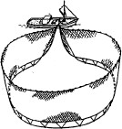These nets catch fish by 1. them from the sides and underneath. They are normally surface nets, with the headline (*relinga*) supported by numerous floats. The net is characterised by the use of a purse line at the bottom of the net, 2. the net to be closed like a purse, thus 3. all the fish within the encircling net. These nets, which may be very large, are usually operated by one vessel, with or without an auxiliary skiff. Figure 25 shows the method of deployment of a purse seine.

###### Seine nets

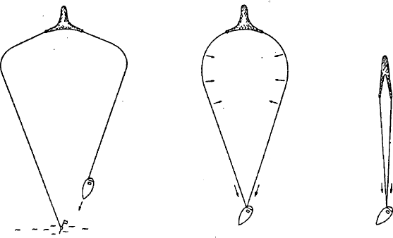**Figure 27** *— Operation of boat seine*

A boat seine net is similar in construction to a trawl net, but with longer wings. The net is 4. on either side to a set of very long ropes, which are set on the seabed and then 5.

as shown in Figure 27. The speed of retrieval is gradually 6.

during the operation.

The fish are 7. between the ropes and subsequently collected in the net. This category has two methods of operation:

* + *Danish seines (anchor seines).* When using the Danish seine method, the vessel is prevented from being dragged backwards during the hauling operation by being 8. .
  + *Scottish seines (fly-dragging).* When using the Scottish seine method, the vessel is prevented from being dragged backwards during the hauling operation by 9. ahead on the main propulsion system.

###### Trawl nets

**Figure 28** *— Typical trawl construction (tapered= gradually narrowing)*

**Figure 35** *—Trawl doors*

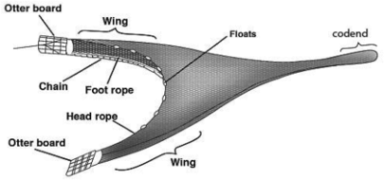

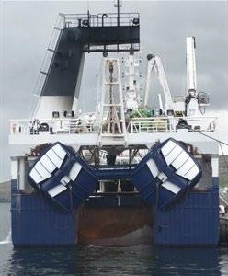Trawls are towed nets consisting of a cone-shaped body that terminates in a closed bag (cod-end) which collects the fish. The front opening (mouth) can be 10.

open, both vertically and horizontally, by a variety of means, 11.

on the type of trawl. Bottom trawls are towed along the seabed to catch demersal (bottom-dwelling) species; midwater trawls are towed anywhere between just off the seabed and the surface to catch pelagic species.

* + *Beam trawls*

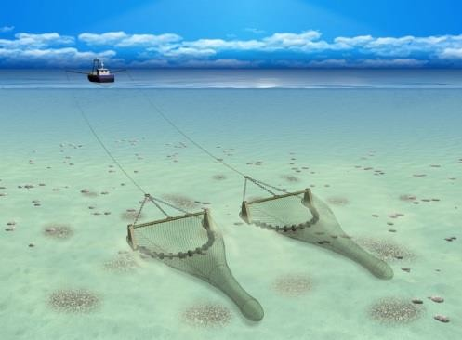In these trawls, the opening is maintained by a beam

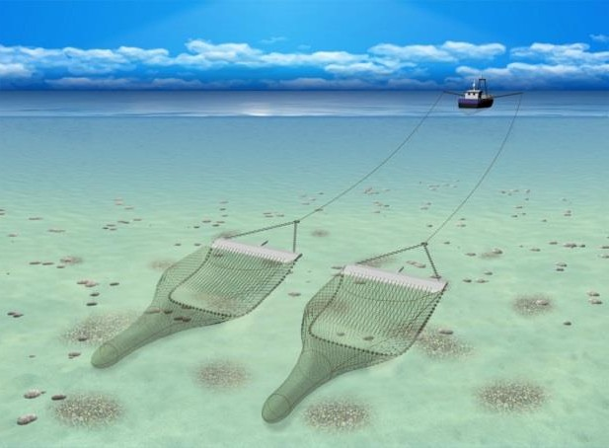made of

wood or, more

commonly, metal. These trawls can be very

heavy, due to the associated ground gear.

There are two common types of beam

trawls, referred to as ‘open gear’ and ‘chain mat gear’. Open gear is a lighter rig with several chains. These ticklers help to disturb the fish from the muddy seabed. This rig is 12.

on clean soft ground. The chain mat or stone mat gear is used for 13.

over rockier areas of seabed. In this rig there is a lattice (*entramado*) work of chains. A recent development in beam trawling is the ***sum wing trawl*** ( last image of previous page), where the beam floats near the bottom and electric pulses (by derogation) in the gear are used to disturb the fish from the seabed. In this fishing method of beam trawling the beam is replaced with 'wing' style of beam without any beam shoes at the ends. The aero foil shaped beam creates lift as it is towed through the water similar to an aeroplane wing. It is designed to skim about 600mm above the seabed with a standard beam trawl net behind it. This gear is often combined with the pulse trawl system.

Beam trawls are used 14. mostly shrimps and flatfish, and are normally towed off derricks, one on either side of the vessel.

* + *Bottom otter trawls*

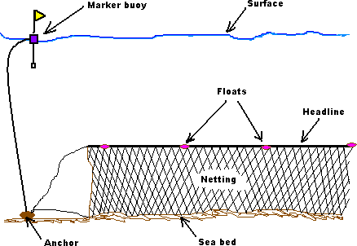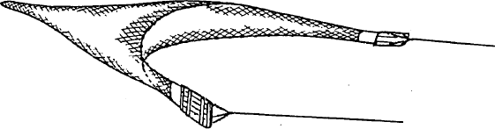These trawls are 15. along the seabed by a single vessel; the horizontal opening is 16.

by otter boards which spread the net by a combination

of hydrodynamic and ground forces. The vertical opening is maintained by floats and sometimes kites.

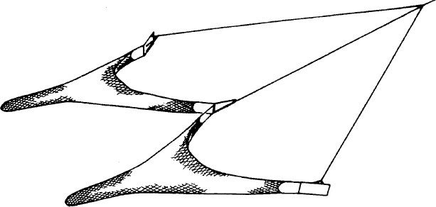**Figure 36** *— Twin trawls*

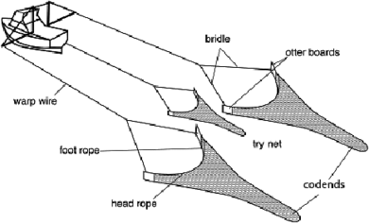More than one otter trawl may be towed simultaneously by a single vessel. Normally two trawls are towed (twin-rig), but recently three

trawls have also 17. common. The inner wings are normally 18.

to a heavy weight or sledge. In certain fisheries, notably for shrimp and flatfish, otter trawls (either single or twin) may be towed from a derrick on either side of the vessel.

* + *Midwater otter trawls*

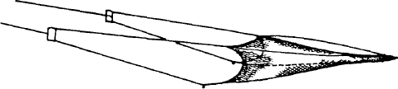**Figure 38** *— Midwater otter trawl*

These trawls are usually much larger than bottom trawls. The front net sections are often 19.

with very large meshes or ropes, to reduce water resistance, which herd the shoals towards the rear of the net. The horizontal opening is 20. by otter boards, usually of a hydrodynamic shape, which normally do not touch the seabed. The depth is controlled by the warp length, vessel speed and wing-end weights.

###### Gillnets and entangling nets

In this type of gear, fish are gilled, entangled or 21. in the netting, which may be either single wall (gillnets) or multiple wall (trammel nets). According to their design, ballasting and buoyancy, these nets may be used to fish on the surface, in midwater or on the seabed.

* + *Set gillnets (anchored)*

**Figure 41** *— Bottom-set gillnet*

These are nets made up of a single piece of netting 22.

vertically in the

water by floats and weights 23. or capable of being 23. by any means to the seabed.

* *Drifting gillnets (driftnets)*

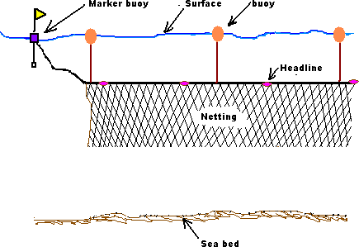**Figure 42** *— Driftnet*

These are nets made up of a single piece of netting 24.

vertically in the water above the seabed by means of floats or buoys. The net is not fixed to the seabed and is free 25.

under the influence of wind or tide.

* *Long lines*

###### Hooks and lines

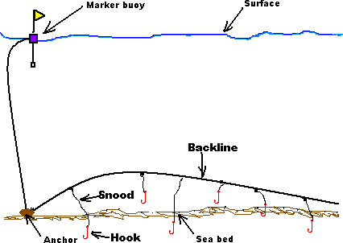

**Figure 46** *— Bottom-set long line*

A long line is a fishing gear which comprises a main line 26.

numerous hooks on branch lines of varying length and spacing, depending on the target species. It may be deployed either vertically or horizontally to the sea surface; it may be 27. either at or near the bottom (bottom-set long line) or drifting in midwater or near the surface (surface long line).

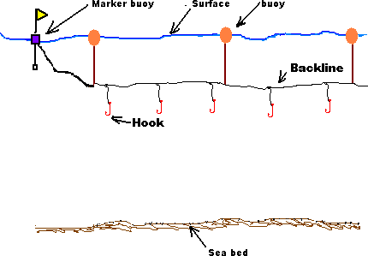

***Figure 47*** *— Surface long line*

###### ENVIRONMENTAL FEATURES

* + **Acoustic deterrent devices**

**Figure 86** *— A selection of acoustic devices*

Current legislation requires that, in certain areas, some bottom-set gillnets and

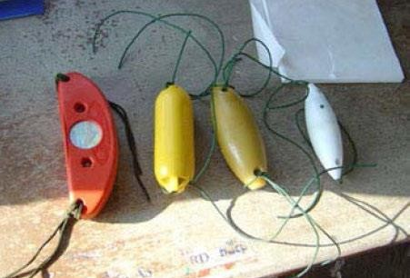driftnets are 28. with

**‘pingers’***(emisor de ultrasonidos).*

acoustic deterrent devices. These devices emit a signal at frequencies 29.

to drive cetaceans (whales, dolphins and porpoises) away from the gear. They are normally referred to as

###### Bird-scaring devices

**Figure 87** *— Mounting of pinger on gillnet*

Seabirds can be accidentally 30. by fishing gear; the most common occurrence is when birds take the baited hooks during the setting of long lines. This can be 31.

by a variety of devices including:

* streamer lines, sometimes called tori lines, where a line containing cloth strips or reflectors is streamed above the long line being set;
* water cannon 32. a covering spray above the long line;
* acoustic scarers.

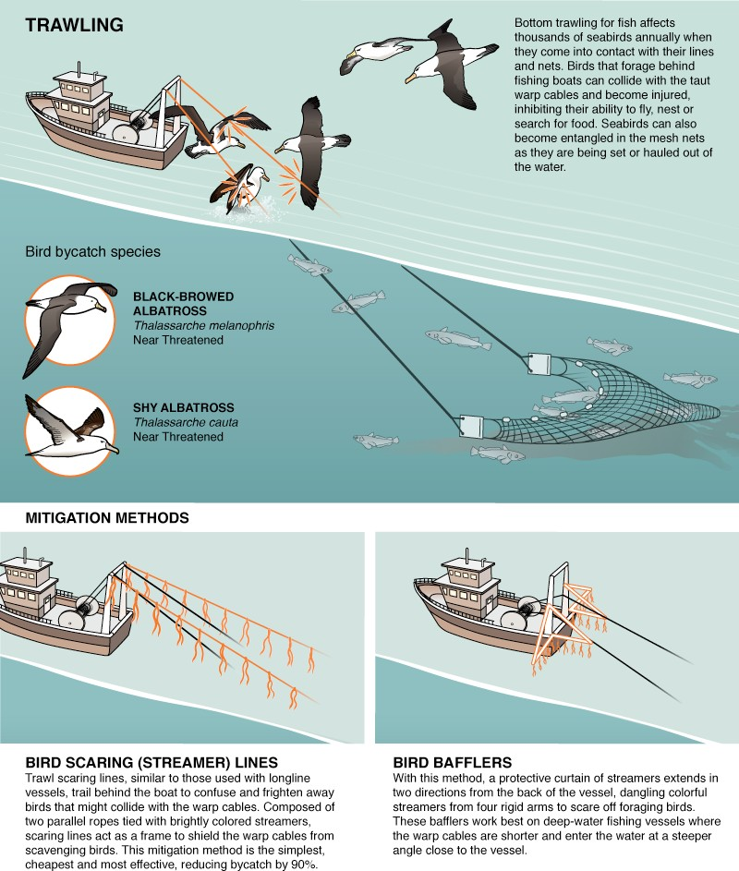

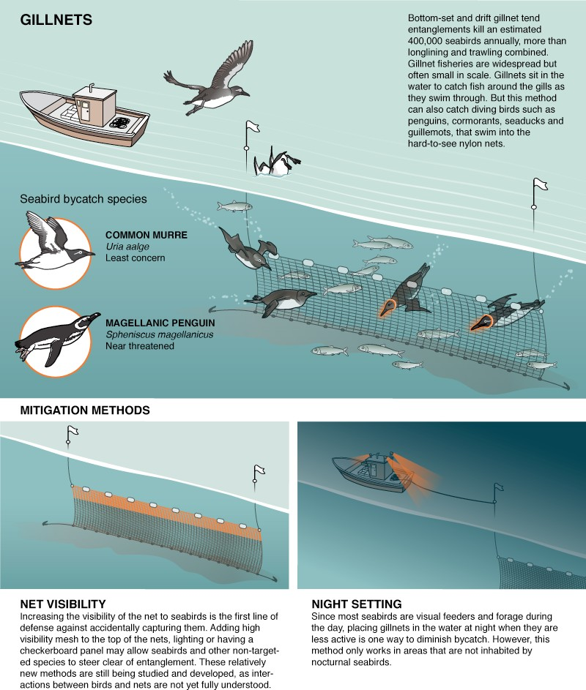

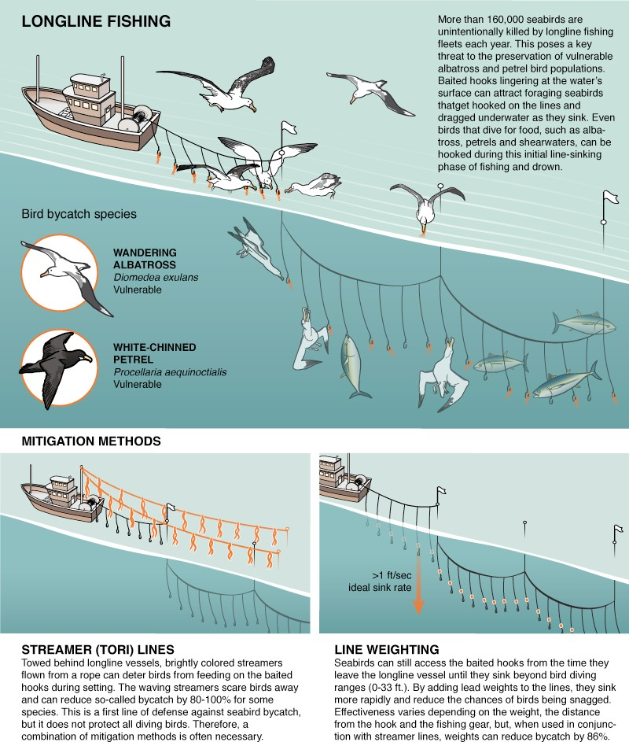

***Exercise. Unite these definitions with the terms defined:***

|  |  |  |
| --- | --- | --- |
|  | **Codline** | ***a)*** Are poles fitted with a flotation device and held upright in the water by a weight; the top of the pole will carry flags, luminous bands and flashing lights, the characteristics of which will  depend on the position of the buoy in relation to the net. |
|  | **A torquetteMedian lacing of a trouser cod-end** | ***b)*** These devices are floating rafts used to attract shoals of pelagic fish; the mechanism appears to be that it provides shelter for smaller fish,  which in turn attract larger predatory species. |

|  |  |  |
| --- | --- | --- |
|  |  | They can either be anchored to the seabed or free-floating; the most common are free-floating ones used to attract tuna which  are then caught by purse seine. |
|  | **Lifting strap** | ***c)*** Is any craft carried aboard a fishing vessel and used to assist in the fishing operation. Most commonly, this will be a skiff used by a  purse seiner to assist with the setting and closing of the seine. |
|  | **Strengthening bags** | ***d)*** Are attachments to the bottom and top of towed fishing gear to prolong the life of the nets by reducing wear and tear from rubbing on the seabed. **Topside ones** can be made of netting, while **bottom(-side) ones** can be made of twine, net and leather strips. A  or protection piece is a  short cylindrical piece of netting at the points of attachment of the lifting strap. |
|  |  | ***e)*** Are used in demersal trawl fisheries to prevent the cod-end from bursting when it is  being lifted aboard the vessel |
|  | **Auxiliary craft** | ***f)*** Is a rope that makes it possible to close the rear of a cod-end or of a strengthening bag. |
|  | **Chafers** | ***g)*** Is a piece of rope or wire loosely encircling the circumference of a cod-end or of any strengthening bag. It is attached to the cod- end or strengthening bag by means of loops or rings. More than one lifting strap may be used at any time |
|  | **Sieve netting** | ***h)*** Is a ring-shaped rope that encircles the cod- end or any strengthening bag at regular  intervals and is attached to it |
|  | **Marker buoys** | ***i)*** Is a piece of netting with a mesh size that is at least twice the mesh size of the cod-end. |
|  | **Round strap** | ***j)*** Is a piece of netting fixed inside the cod-end at its rear end. |
|  | **Fish-aggregating devices**  (**FAD** | ***k)*** In order to build one, meshes may be tied up together by joining lengthways the upper and lower halves of a cod-end. |

###### EXAMPLES OF ILLEGAL ATTACHMENTS IN COMMON USE

There are certain illegal attachments which may be encountered, the purpose of all of them being to restrict the mesh openings and therefore retain smaller fish. The most commonly detected of these are the following:

###### Blinder netting

Blinder netting is a piece of netting with a mesh size less than that of the cod-end, which is inserted inside the cod-end. It is generally a tube-like construction and is laced by its forward edge to the cod-end netting. Normally, the lacing will only be attached at a few points, making it very easy for the fisherman to cut the lacing, and the blinder falls out of the cod-end when

the catch is released. The fisherman can then claim that the blinder is in fact a piece of stray netting which was trawled up during the fishing operation. Detecting this type of attachment can only be achieved by being present while the cod-end is brought aboard and emptied.

###### Illegal round straps

Round straps which are shorter than the required length have a significant impact on the selectivity of the net, by preventing the meshes from opening. Fixed round straps of this type are easily detected; however, there is a system of illegal round straps in frequent use which is

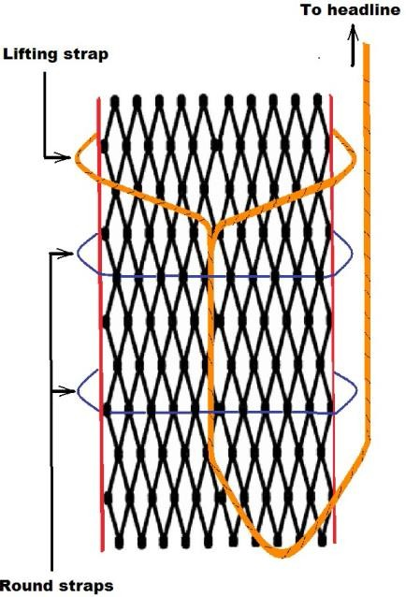much harder to detect. In this case, the round straps are made of a circle of light twine which is rove *(enhebrado)* through the cod-end netting. The lifting strap is passed backwards, under these round straps, before leading forward to the headline. When the net reaches the surface, the lifting strap is taken from the headline and hauled in. As the lifting strap is pulled forward, it breaks through the weak round straps and when the cod-end is brought aboard, there is no evidence of the round straps, except perhaps for some ends of twine rove through the cod-end meshes (but no illegal round strap good enough for evidential purposes). The only way to detect this practice is to insist that the lifting strap is not hauled upon until the cod-end has been inspected. This can be done by putting a boarding boat next to the cod-end in the water, when it is streamed alongside the fishing vessel. If the presence of this type of attachment is detected, then the inspector should ensure that the

cod-end is brought aboard without undue heaving on the lifting strap. In this way, the illegal round straps can be retrieved intact.

###### Illegal chafers

Another illegal practice seen is that of tying together the two outside edges of a bottom-side chafer over the top of the cod-end. The edges are tied with weak twine. This has the effect of restricting the opening of the cod-end meshes, especially on the top side, where most fish escape from. When the cod-end is hauled aboard, the weight of the fish causes the ties to break, leaving no evidence of the practice. Once again, this is very hard to detect and the inspector must try to retain the cod-end with the ties intact, which is very difficult in practice. NB: The use of the above devices is to retain smaller fish, which can still be of marketable size, either by being above the minimum landing size or because there is no minimum size. The inspector should make himself familiar with the fisheries in the area, which will give a good indication of where such devices are likely to be in use. Normally, the devices are used where there is a good commercial demand for smaller fish, generally in mixed fisheries.

#### HIGH SEAS BOARDING INSPECTION

**STANDARDIZED MULTI-LANGUAGE QUESTIONNAIRE**

###### BOARDING QUESTIONS

1. FISHING VESSEL THIS IS THE (***PATROL VESSEL (United States Coast Guard***

***Cutter, Her Majesty’s Australian Ship, etc.***) CALLING YOU ON CHANNEL 16 VHF-FM/2182 khz (HF) OVER.

1. REQUEST YOU SWITCH YOUR COMMUNICATIONS TO CHANNEL .
2. FISHING VESSEL (NAME), THIS IS PATROL VESSEL (NAME) WE ARE HERE ON BEHALF OF

THE WESTERN AND CENTRAL PACIFIC FISHERIES COMMISSION AND ARE AUTHORIZED TO ENSURE YOU ARE COMPLYING WITH ALL APPLICABLE CONSERVATION AND MANAGEMENT MEASURES. WE INTEND TO BOARD AND INSPECT YOUR VESSEL. PRIOR TO OUR BOARDING OF YOUR VESSEL, WE NEED TO ASK YOU A FEW QUESTIONS.

1. IS YOUR VESSEL REGISTERED WITH ***THE WESTERN AND CENTRAL PACIFIC FISHERIES COMMISSION***?
2. UNDER WHICH COUNTRY’S FLAG ARE YOU REGISTERED?
3. WHAT IS YOUR INTERNATIONAL RADIO CALL SIGN?
4. WHAT IS YOUR HOMEPORT?
5. HOW MUCH FISH (Fishing Vessel) DO YOU HAVE ONBOARD? WHAT TYPE?
6. WHAT WAS YOUR LAST PORT OF CALL?
7. WHAT IS YOUR NEXT PORT OF CALL?
8. WHAT IS THE NAME AND NATIONALITY OF YOUR MASTER?
9. HOW MANY CREW DO YOU HAVE ONBOARD AND WHAT ARE THEIR NATIONALITIES?
10. DO YOU HAVE ANY WEAPONS ONBOARD? IF SO, WHERE ARE THEY LOCATED?
11. DO YOU HAVE A FISHERY OBSERVER ONBOARD? IF SO, WHAT IS THE OBSERVER’S NAME AND NATIONALITY?
12. WE WILL BE SENDING OVER A BOARDING PARTY IN (FIVE / FIFTEEN / THIRTY) MINUTES; PLEASE ASSIST THEM IN GETTING ONBOARD AND BY COMPLYING WITH ALL OF THEIR INSTURCTIONS.
13. TO ASSIST OUR BOARDING PARTY IN BOARDING YOUR VESSEL, WE REQUEST YOU :
    1. STOP YOUR VESSEL
    2. SLOW YOUR VESSEL
    3. CONTINUE ON YOUR PRESENT COURSE AND SPEED
    4. TURN TO (PORT / STARBOARD)
    5. LOWER A LADDER ON THE (PORT / STARBOARD) SIDE
14. TO CONDUCT THIS INSPECTION IN A TIMELY MANNER, PLEASE MAKE AVAILABLE TO OUR BOARDING OFFICER ALL OF YOUR VESSEL’S DOCUMENTS, INCLUDING YOUR CATCH LOGS AND REPORTS.

###### INITIAL BOARDING QUESTIONS

1. GOOD (MORNING / AFTERNOON / EVENING), ARE YOU THE MASTER OF THE VESSEL?
2. I AM HERE TO INSPECT YOUR VESSEL FOR COMPLIANCE WITH MEASURES ADOPTED BY ***THE WESTERN AND CENTRAL PACIFIC FISHERIES COMMISSION***
3. DO YOU UNDERSTAND?
4. IS THERE ANYONE HERE WHO SPEAKS ENGLISH?
5. I DO NOT HAVE ANYONE ONBOARD WHO CAN SPEAK YOUR LANGUAGE.
6. I AM USING BILINGUAL LANGUAGE CARDS. PLEASE ANSWER MY QUESTIONS SIMPLY AND SLOWLY, USING YES AND NO WHENEVER POSSIBLE
7. THESE PEOPLE WILL ASSIST ME IN MY INSPECTION
8. PLEASE MUSTER YOUR CREW ON THE (FANTAIL (popa lanzada) / BOW / OPEN DECK)
9. PLEASE INDICATE WHERE YOU KEEP YOUR WEAPONS ONBOARD
10. THIS IS A COPY OF THE TEXT OF ***THE WESTERN AND CENTRAL PACIFIC FISHERIES CONVENTION*** WHICH PROVIDES ME THE AUTHORITY TO BOARD YOUR VESSEL AND CONDUCT THIS INSPECTION
11. PLEASE REVIEW THIS DOCUMENT AND LET ME KNOW IF YOU HAVE ANY QUESTIONS
12. THIS IS A COPY OF THE RELEVANT COMMISSION CONSERVATION AND MANAGEMENT MEASURES WHICH APPLY TO YOUR VESSEL
13. WHEN WERE YOU INSPECTED LAST? WHO INSPECTED YOU?
14. I INTEND TO INSPECT YOUR VESSEL TO ENSURE YOUR COMPLIANCE WITH THESE CONSERVATION AND MANAGEMENT MEASURES
15. PLEASE SHOW ME
    1. YOUR VESSEL’S DOCUMENTS
    2. YOUR CURRENT PERMITS
    3. YOUR CATCH LOGS
    4. YOUR PLOTTING CHARTS
16. YOUR DOCUMENTS AND RECORDS INDICATE YOU ARE IN COMPLETE COMPLIANCE WITH ALL COMMISSION CONSERVATION AND MANAGEMENT MEASURES
17. YOUR DOCUMENTS AND RECORDS INDICATE YOU ARE NOT IN COMPLETE COMPLIANCE WITH ALL CONSERVATION AND MANAGEMENT MEASURES
18. THIS IS THE SPECIFIC CONSERVATION AND MANAGEMENT MEASURE BY WHICH YOU ARE NOT IN COMPLIANCE
19. THIS (IS / IS NOT) CONSIDERED BY THE COMMISSION TO BE A SERIOUS VIOLATION
20. I AM SEIZING (incautar) THIS ITEM FOR EVIDENCE
21. I AM PHOTOGRAPHING THIS ITEM TO DOCUMENT THE VIOLATION

22.I WILL USE THIS BOARDING REPORT TO DOCUMENT MY INSPECTION OF YOUR VESSEL

1. THIS BOARDING REPORT INDICATES YOU (ARE / ARE NOT) IN COMPLIANCE WITH ALL COMMISSION CONSERVATION AND MANAGEMENT MEASURES
2. THIS IS YOUR COPY OF THE BOARDING REPORT
3. A COPY OF THIS BOARDING REPORT WILL BE PROVIDED TO THE FISHERIES ENFORCEMENT AUTHORITIES OF YOUR COUNTRY (FOR FURTHER ACTION)
4. THANK YOU FOR YOUR ASSISTANCE ON THIS BOARDING
5. I HAVE COMPLETED THE INSPECTION OF YOUR VESSEL
6. WE ARE DEPARTING YOUR VESSEL AT THIS TIME